research website overview

Nov 28th 2019, Written by Julie Lee

Table of Contents

1. introduction 3

A. User Roles 3

i. Employee 3

ii. Application Manager 3

iii. Developer 3

iv. User Admin 3

v. Publisher 3

2. Employee’s View 3

A. Dashboard 3

i. Latest Articles tab 4

ii. Publications from Your Connections tab 4

iii. Articles you might be Interested In tab 4

B. New Submission 6

C. Profile 6

3. Publisher’s View 9

A. Publish 9

i. Submissions available to review for publication 9

ii. Submissions returned for revision 9

B. Manage Users 10

C. Settings 10

i. Submission scroll setting 11

ii. Public access setting 11

iii. Additional notification setting 11

iv. Email digest recent days setting 11

D. Weighting Factors 11

i. View score 11

ii. Following score 11

iii. Interest score 11

iv. Profile access score 12

E. Submission Types 12

F. Tags 12

# introduction

This is a brief explanation document on how the GBC Research Website works. The URL for the website is: <https://dmzmsa02.georgebrown.ca/Research/>

## User Roles

### Employee

An employee is a regular user. You can log in as Fredrick Fiddler (ID: fred, Password: fred) to see what it looks like as an employee.

### Application Manager

### Developer

### User Admin

### Publisher

The publisher is the role that can manage the submissions. The person can delete, publish, return for revision, create, and edit any submissions the employee has submitted.

# Employee’s View

## Dashboard

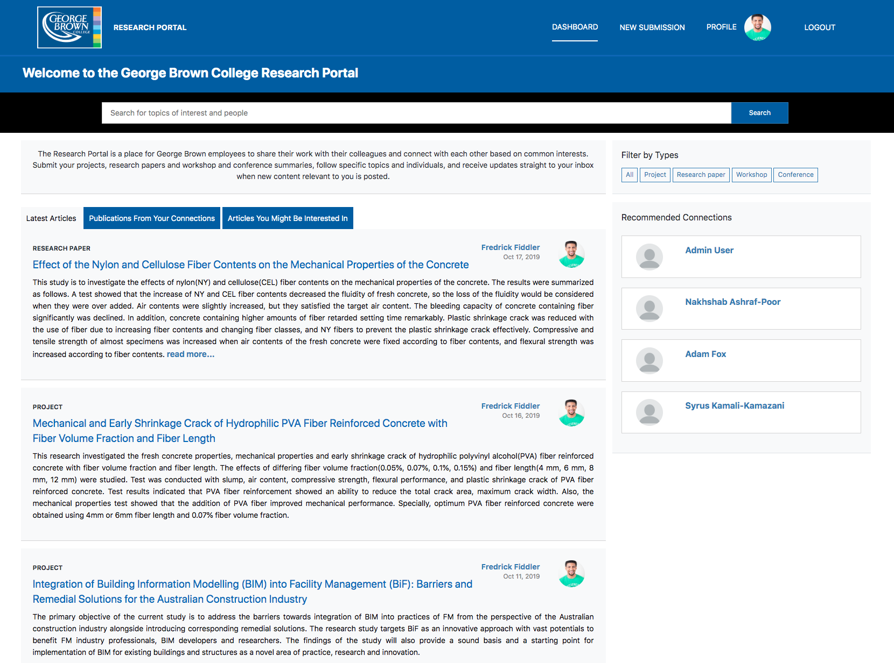

Figure . Dashboard from Employee's View

If you log in as Fredrick Fiddler’s account, Dashboard is the first page you would see. It contains all of the published submissions the users have made (including yourself).

It has three tabs, Latest Articles, Publications from your Connections, and Articles you might be Interested in.

### Latest Articles tab

It contains all submissions, and you can filter these submissions by types.

### Publications from Your Connections tab

It contains the submissions from your followings.

### Articles you might be Interested In tab

It contains the submissions with the same tag as your interest tags.

Recommended Connections uses a user matching algorithm to calculate the recommended user list for the specific user. The factors that were accounted for include the following: view score, following score, interest score, and profile access score. This scoring algorithm will be mentioned more thoroughly in Weighting Factors.

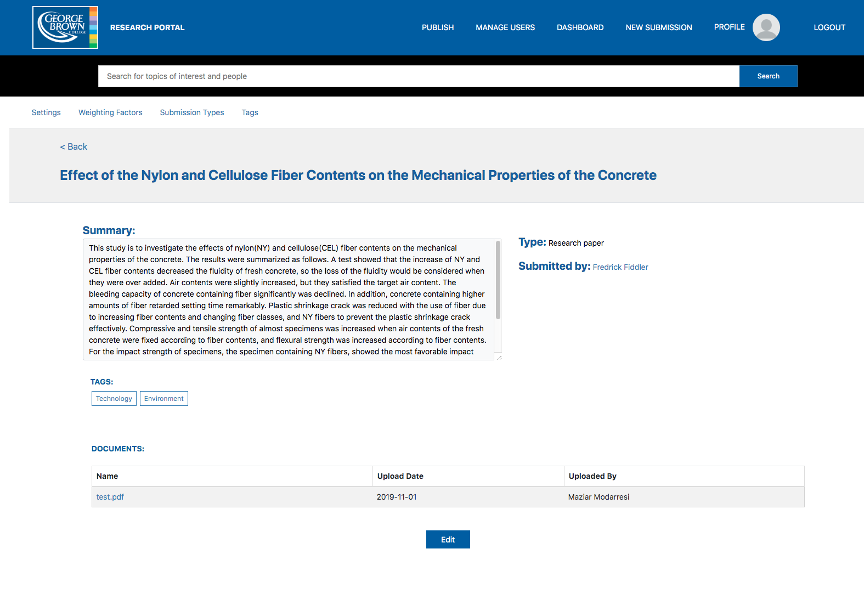

Figure . Submission from Research View from the User

If you click on the title, you will see something like Figure 2. You will be able to download the documents attached to the submission, see the summary, and click on the submitter’s profile. Also, if you click on the tag, you will be directed to the list of the submissions with the same tag.

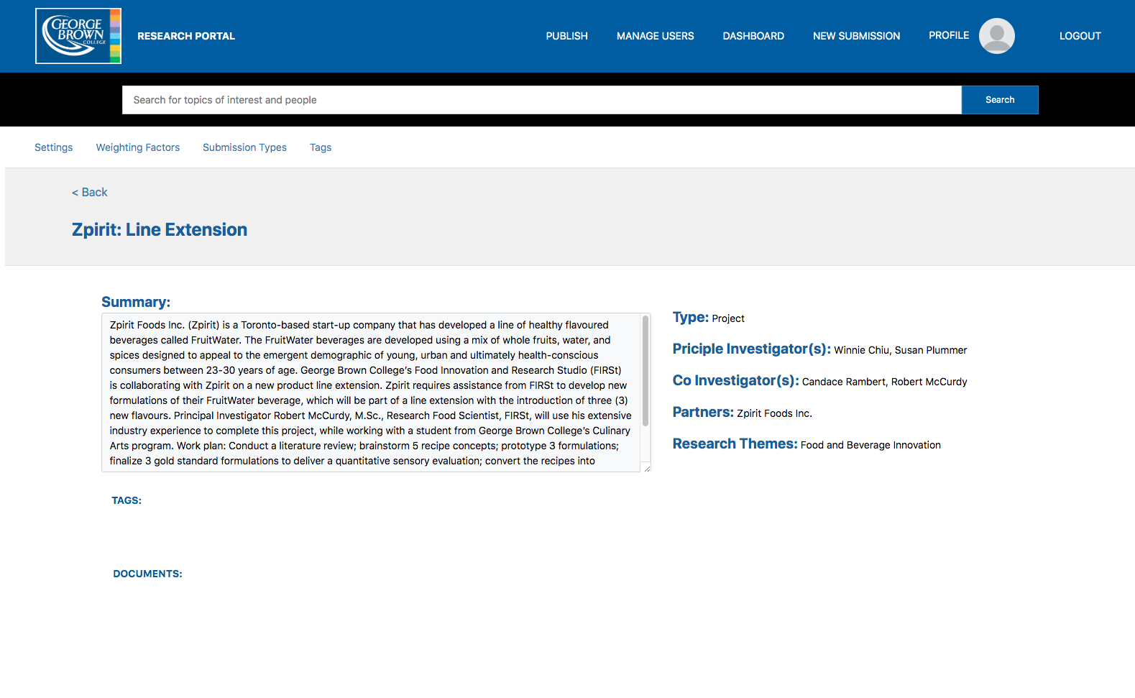

Figure . Submission from IAGO View from the User

We have two different sources for the submissions: one from the Research website, and one from IAGO. The one from IAGO cannot be edited nor deleted, no matter what. Also, the submitter format is different for IAGO, so instead of submitter, they have principal investigator, co-investigator, partner, and research themes.

## New Submission

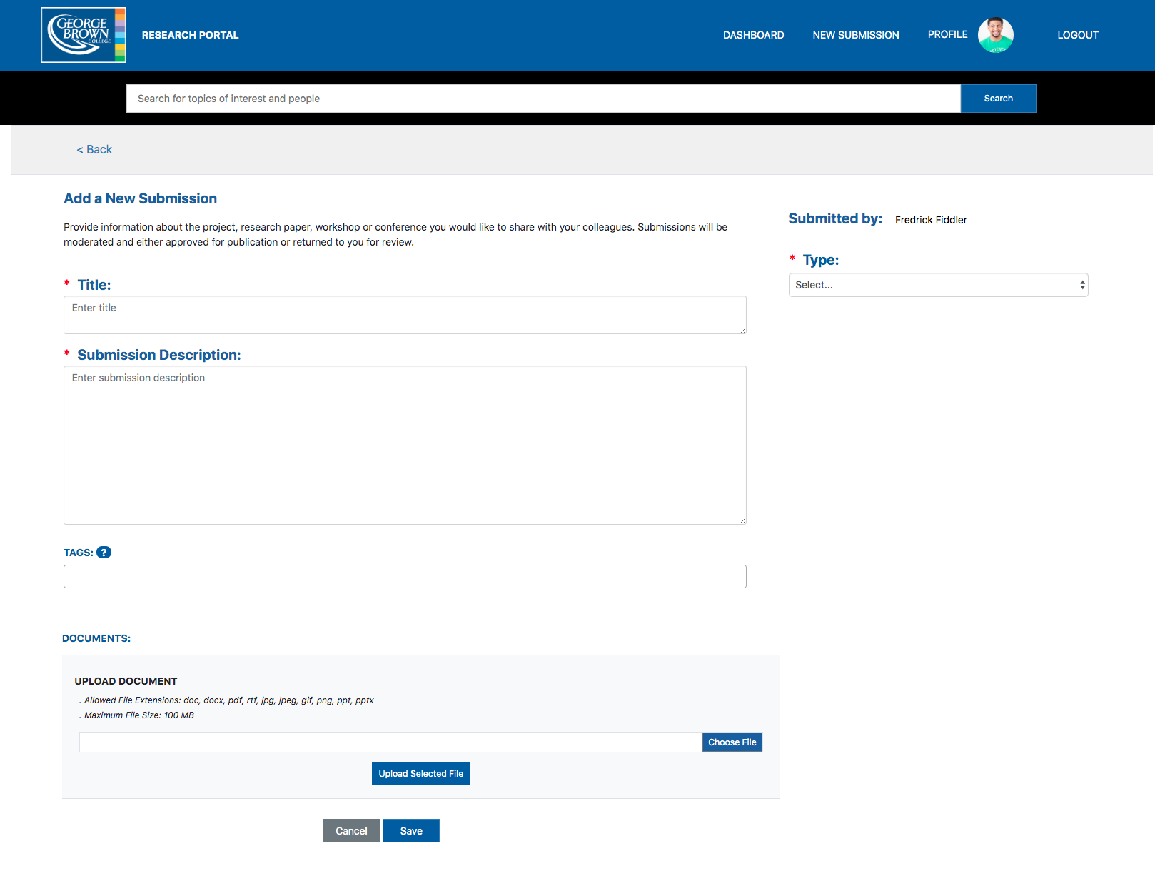

Figure . New Submission from Employee's View

As can be assumed from the name, this is used to create a new submission for the users. The submission is composed of five sections, including Title, Description, Tags, Type, and Documents.

The title is required to save the submission, while Title, Description, and Type have to be filled to be submitted to publication.

For Tags, the employees will have a drop-down list of all the existing and enabled tags. However, if they wish to add a new tag for their submission, they would need to get approval from the publisher. If the tag has not been enabled yet, it will appear with an orange-colored background; the regular tag will have a white-colored background. This part will be explained in the Tags section.

For Documents, we allow only certain file extensions including doc, docx, pdf, rtf, jpg, jpeg, gif, png, ppt, and pptx. Also, we restrict the maximum file size to 100 MB. When the user clicks the “Upload Selected File” button, it automatically saves the submission. Therefore, if the title has not been filled at that point, it will require a user to fill out the title first.

## Profile

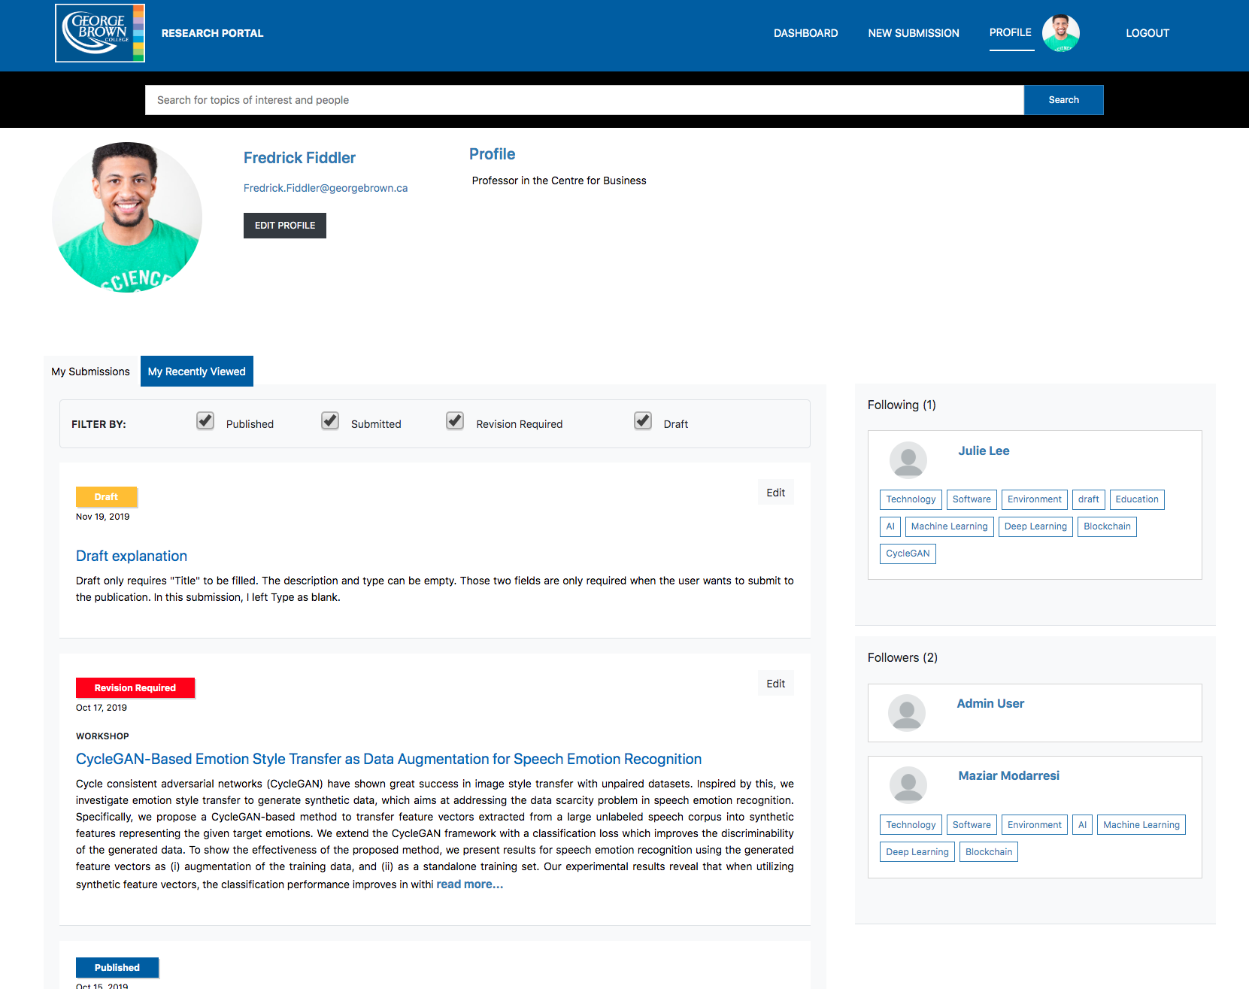

Figure . My Profile from Employee's View

On Profile, the user can set their profile picture, biography, privacy settings, notification settings, interests, and pagination settings.

The users can decide whether they want to show their email, interest, and recently viewed tab to other people or not. Also, they can set the email digest settings.

The Profile also shows the “My Recently Viewed” tab, which shows the latest 10 published submissions the user has viewed.

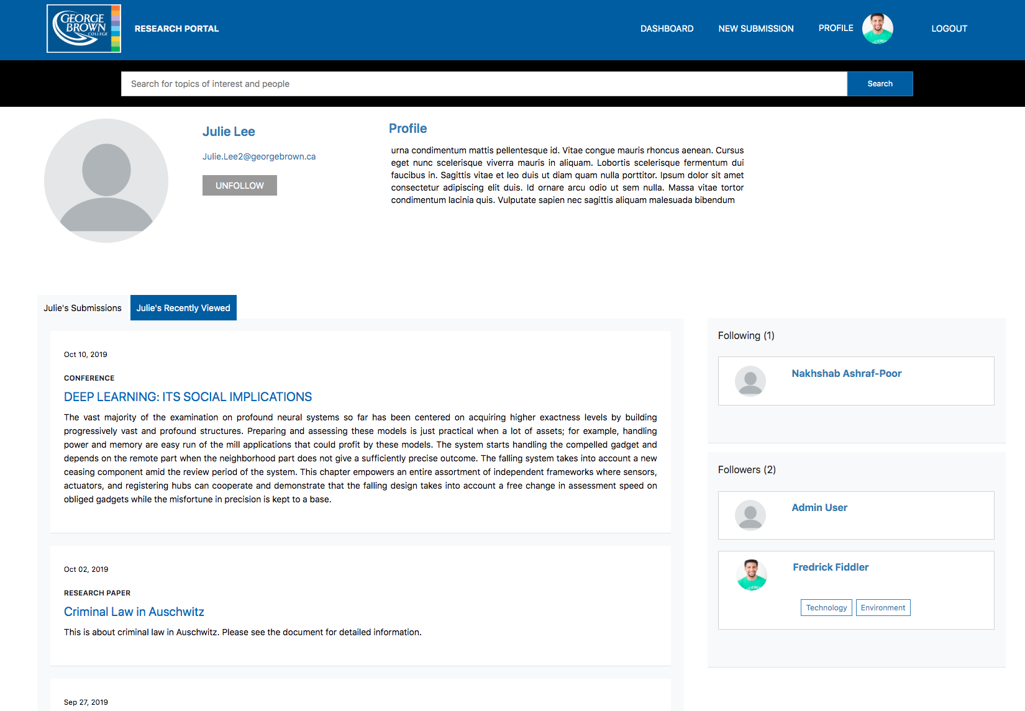

Figure . Another User's Profile from Employee's View

If you visit another user’s profile, you have an option to “follow” or “unfollow” that user. If you decide to follow that user, you will appear in their “Followers” list, and that person will appear in your “Following” list. Depending on your “Show my interests” setting, your interest tags will also show up there.

# Publisher’s View

For simplicity, I will not mention about Dashboard, New Submission, and Profile as they are almost the same as the employee’s view. The only difference would be that the publisher can edit any published submissions.

## Publish

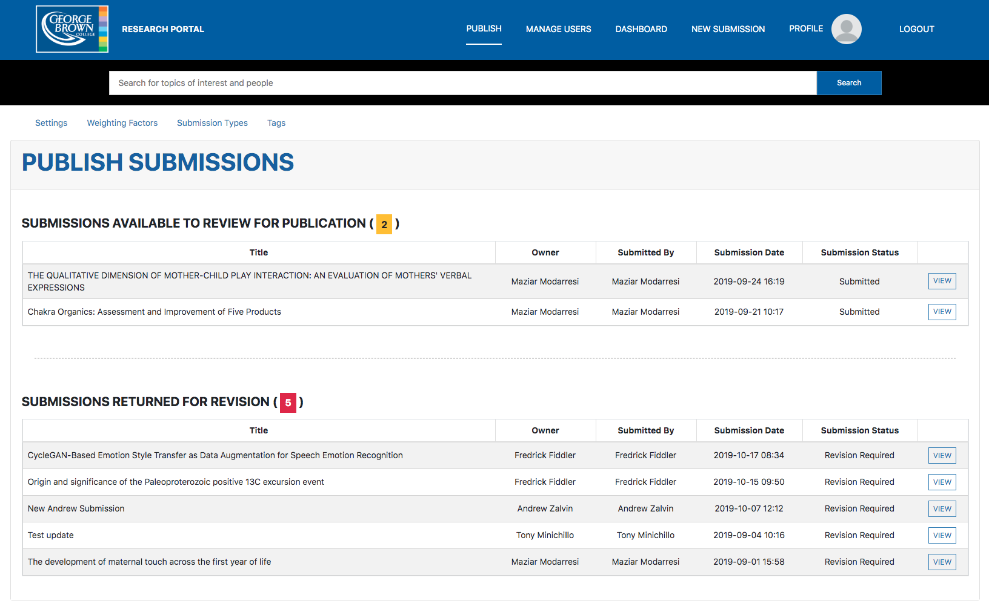

Figure . Publish from Publisher's View

### Submissions available to review for publication

This table contains the submissions that have been submitted by the employees and are ready to be reviewed by the publisher. Here, the publisher will review the content of the submission, and he/she can decide whether they want to publish it or return it for revision.

### Submissions returned for revision

This table includes the returned submissions. Note that the publisher does not have any editability for these submissions as the submission status is “Returned for Revision,” not “Submitted.” The publisher can only *view* the submission and see the reason for the revision.

## Manage Users

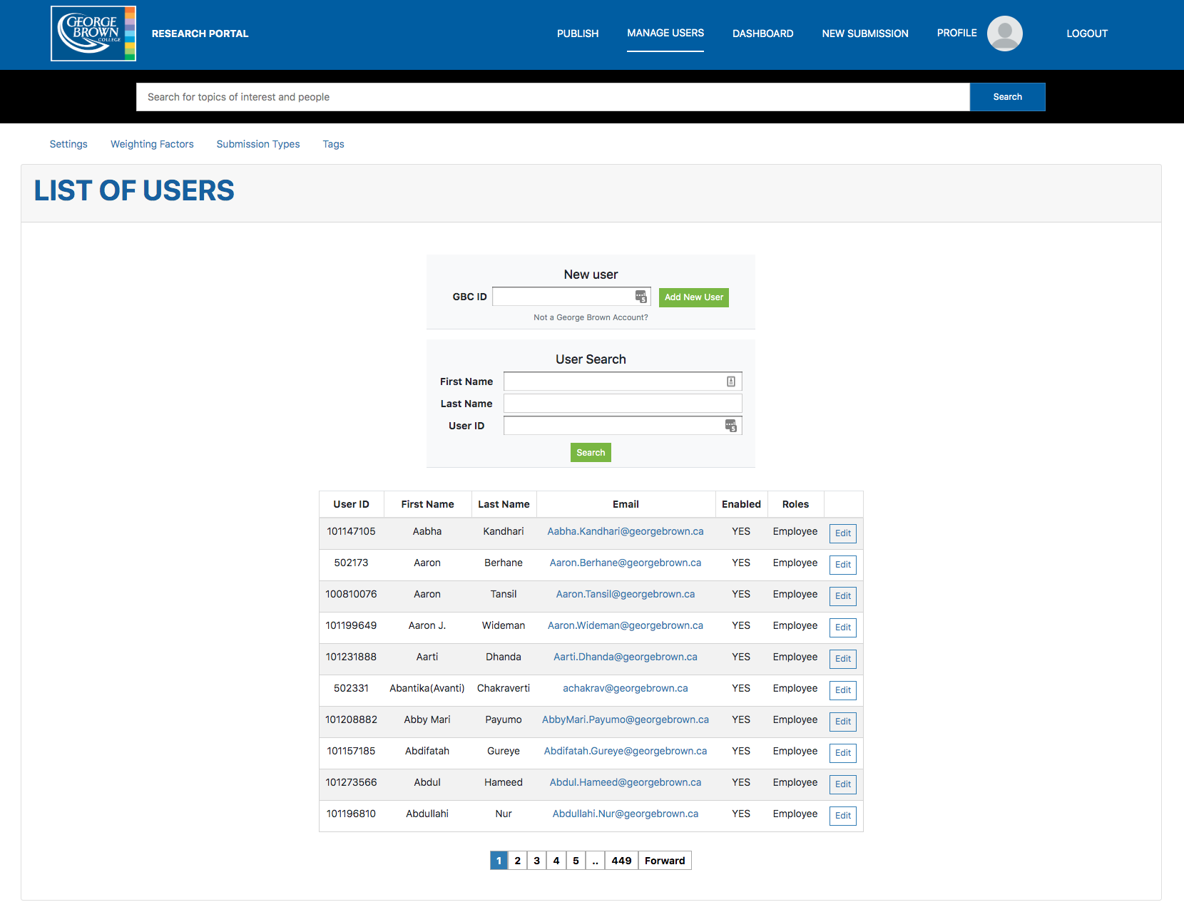

Figure . Manage Users from Publisher's View

In the Manage Users tab, the user admin can access any users and change their roles. Note that all of the employees are added by default, and their accounts will be enabled when they first log in to the website.

## Settings

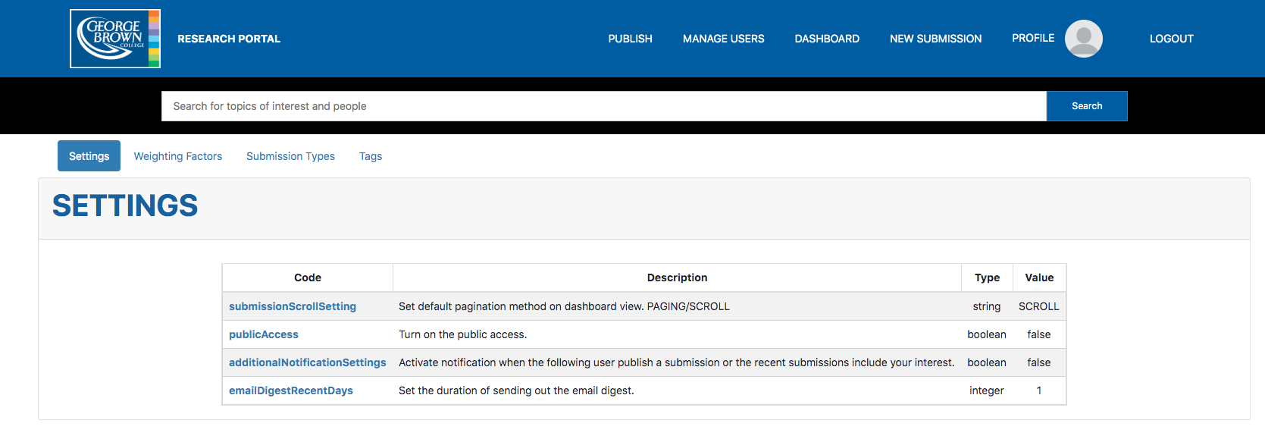

Figure . Settings from Publisher’s View

The publisher can change certain settings on this page.

### Submission scroll setting

This is the setting to set the default pagination method. You can select between Scroll and Paginate.

### Public access setting

You can set whether you want to turn on public access page or not.

### Additional notification setting

### Email digest recent days setting

You can use this setting to set how often you want to send out the email digest to the users.

## Weighting Factors

Note that A refers to the current user and B refers to other users.

### View score

#### View score A to B

This score increases when A views B’s submissions. It only increases once a day.

#### View score B to A

This score increases when B views A’s submissions. It also only increases once a day.

#### View score same content

This score increases when A and B viewed the same content.

#### View recency factor

This is a recency factor that will be used to calculate the view score. If the person viewed the content a long time ago, the score would increment with less amount.

#### View score general

This factor determines the general portion of the view score among others.

### Following score

#### Following score B follows A

This score increases when B is following A.

#### Following score mutual followers

This score increases when A and B have the same follower.

#### Following score mutual followings

This score increases when A and B have the same following.

#### Following recency factor

#### Following score general

### Interest score

#### Interest score same tags

This score increases when A and B have the same interests.

#### Interest score interest from A matching tag from B

This score increases when B’s submission has the same tags as A’s interest.

#### Interest score general

### Profile access score

#### Profile access score A clicking B

This score increases when A clicks on B’s profile (once a day).

#### Profile access score B clicking A

This score increases when B clicks on A’s profile (once a day).

#### Profile access recency factor

#### Profile access score general

## Submission Types

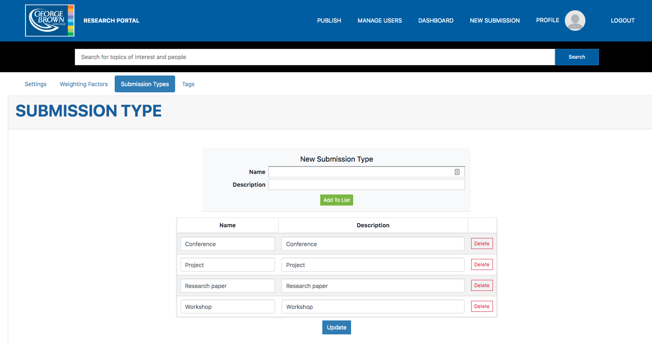

Figure . Submission Types from Publisher's View

In Submission Types, you can manage all the types for the submissions. There are currently 4 types, including Conference, Project, Research Paper, and Workshop.

Note that you cannot delete the type if there is any existing submission with that type. You must delete or change all the submissions before you delete the type.

## Tags

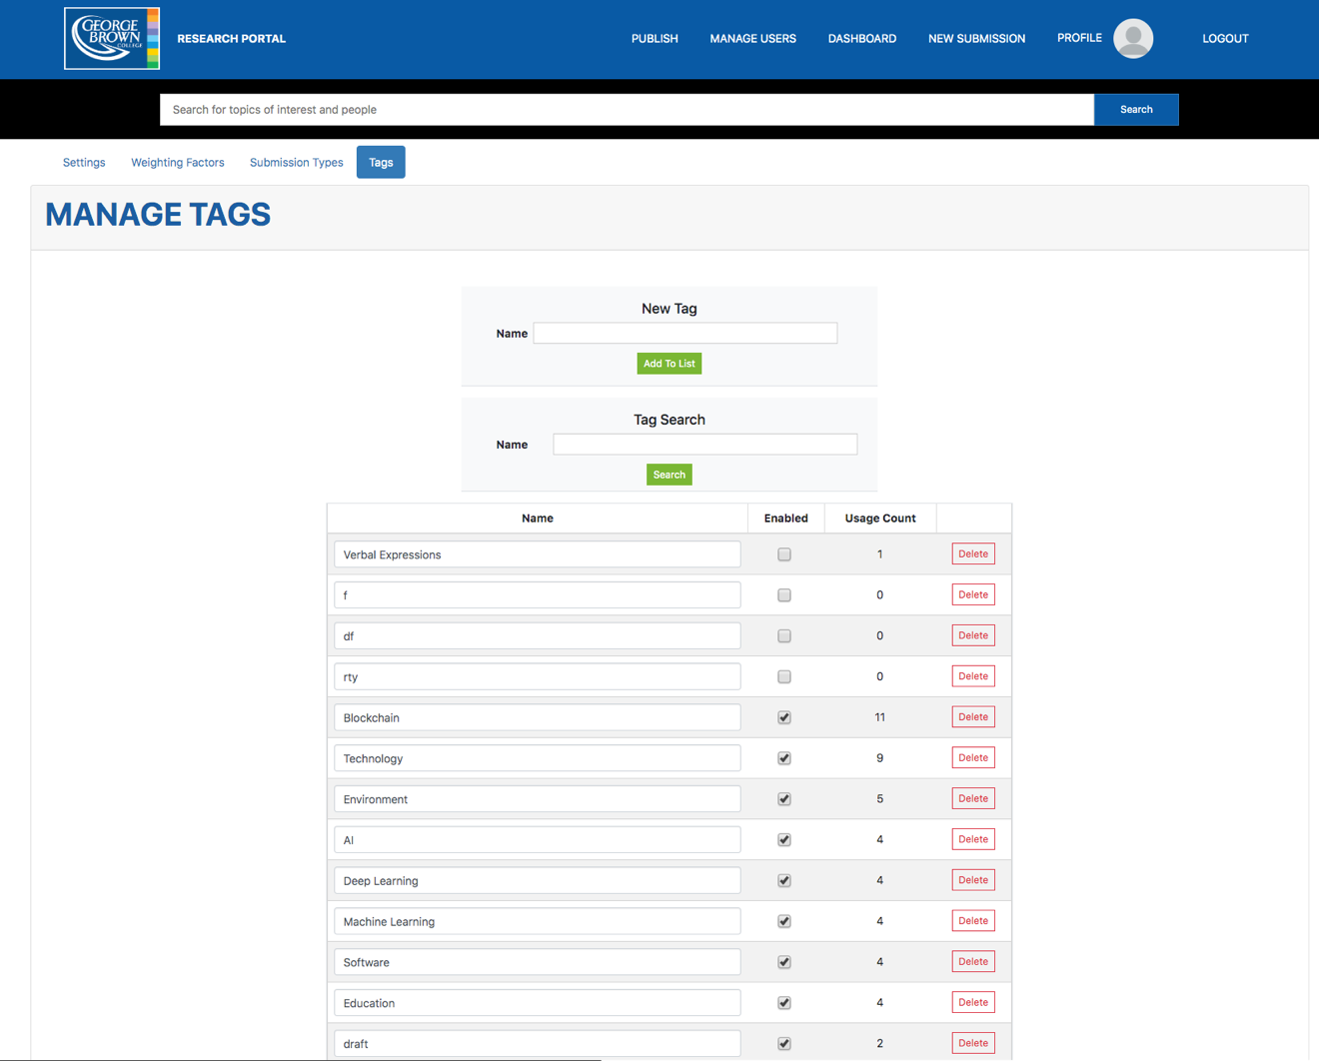

Figure . Tags from Publisher's View

In Tags section, you can manage all of the enabled and disabled tags. When the user adds a new tag on their submission, you will be able to see it here disabled. If you publish the submission with a disabled tag, the employees won’t be able to see it on the Dashboard, and only the publishers will be able to see it in the “edit” mode. Once you enable the tag, the background color for that specific tag will change from orange to white, and it will become public for everyone.

This section also applies to the Interests; unlike the tags for the submissions, when the user sets their interest tags, they can only use the drop-down list. The publisher would need to make sure all the tags they want are enabled.